CPE301 – SPRING 2019

Design Assignment 2C

Student Name: Geovanni Portillo

Student #: 8000603824

Student Email: [portig1@unlv.nevada.edu](mailto:portig1@unlv.nevada.edu)

Primary Github address: <https://github.com/portig1/submissions_E>

Directory: submissions_E/DA/LAB2C/

Submit the following for all Labs:

1. In the document, for each task submit the modified or included code (only) with highlights and justifications of the modifications. Also, include the comments.
2. Use the previously create a Github repository with a random name (no CPE/301, Lastname, Firstname). Place all labs under the root folder ESD301/DA, sub-folder named LABXX, with one document and one video link file for each lab, place modified asm/c files named as LabXX-TYY.asm/c.
3. If multiple asm/c files or other libraries are used, create a folder LabXX-TYY and place these files inside the folder.
4. The folder should have a) Word document (see template), b) source code file(s) and other include files, c) text file with youtube video links (see template).

1. **COMPONENTS LIST AND CONNECTION BLOCK DIAGRAM w/ PINS**

Atmel Studio 7

ATmega328PB Xplained mini

Multi-function Shield

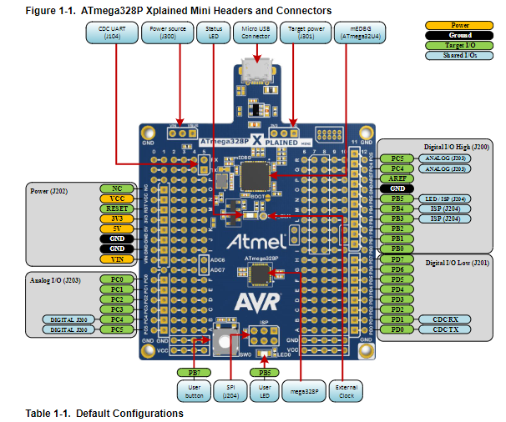

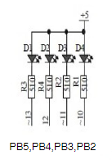

Multifunction Shield LED schematic

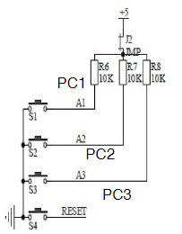

Multifunction Shield Switch Schematic

1. **INITIAL/MODIFIED/DEVELOPED CODE OF TASK 1/ PART1**

#include<avr/io.h>

int main(void)

{

TCCR0A = 0; // Normal Operation

DDRB |= (1 << DDB2); //PB2 as output

TCCR0B |= (1 << CS02) | (1 << CS00);

// set prescaler to 1024 and start the timer

int onCount, offCount;

//For a period of 0.725s with a duty cycle of 60%, LED is on for 0.435s and off for 0.29s

while (1)

{

onCount = 0;

offCount = 0;

TCNT0=0x00; // start the timer

//Using formula TCNT = (clock/prescaler*desired_time_in_seconds) - 1, calculated that a delay of 0.435s and a prescaler of 1024 requires 6795.875 for TCNT. TCNT0 can only count to 255 so 26 iterations are needed along with an additional count to 140 to achieve approximately 0.435ms

PORTB = (0 << 2); //Turn on LED

while(onCount < 26)

{

while ((TIFR0 & 0x01) == 0);

TCNT0=0x00;

TIFR0=0x01; // reset the overflow flag

onCount++;

};

while(TCNT0 < 140);

TCNT0=0x00; // restart the timer

//identical calculations for 0.29s, we end up with 17 iterations and a final count up to 179

PORTB = (1 << 2);

while(offCount < 17)

{

while ((TIFR0 & 0x01) == 0);

TCNT0=0x00;

TIFR0=0x01; // reset the overflow flag

offCount++;

};

while(TCNT0 < 179);

}

}

1. **INITIAL/MODIFIED/DEVELOPED CODE OF TASK 1/ PART2**

#include<avr/io.h>

int main (void)

{

/* set PORTB.2 for output*/

DDRB |= (1 << 2);

PORTB |= (1 << 2);

/* set PORTC.2 for input*/

DDRC &= (0 << 2);

PORTC |= (1 << 2); //enable pull-up

/* A switch is connected to PORTC.2 and when pressed PINC.2 is set low. */

TCCR0A = 0; // Normal Operation

TCCR0B |= (1 << CS02) | (1 << CS00); // set prescaler to 1024 and start the timer

int overflowCount = 0;

//From the same calculations of Task1_Part1, for a 1.25s delay 76 overflows need to occur and a count of 75 cycles.

while (1) {

if(!(PINC & (1 << PINC2)))

{

PORTB &= ~(1 << 2);

TCNT0=0x00; // reset counter

TIFR0=0x01; // reset the overflow flag

while(overflowCount < 76)

{

while ((TIFR0 & 0x01) == 0);

TCNT0=0x00;

TIFR0=0x01; // reset the overflow flag

overflowCount++;

};

while(TCNT0 < 75);

overflowCount = 0;

}

else

PORTB |= (1 << 2);

}

return 0;

}

1. **INITIAL/MODIFIED/DEVELOPED CODE OF TASK 2/ PART1**

#include<avr/io.h>

#include <avr/interrupt.h>

//global variables

int overflowCounter = 0;

int main(void)

{

DDRB |= (1 << DDB2); //PB2 as output

TIMSK0 |= (1 << TOIE0);

TCNT0 = 0; // initial value

sei(); //enable interrupts

int cycleStatus = 1; //cycle status will be for if duty cycle should be in on portion(1) or off portion(0)

TCCR0B |= (1 << CS02) | (1 << CS00); // set prescaler to 1024 and start the timer

//For a period of 0.725s, LED is on for 0.435s and then off for 0.29s. Calculations are reused from Task1_Part1

while (1)

{

if((overflowCounter >= 26) & (cycleStatus == 1)) {

while (TCNT0 < 140);

PORTB = (1 << 2);

cycleStatus = 0;//set so that the LED stays off until the the cycle goes through its "off" portion

}

else if((overflowCounter >= 44) & (cycleStatus == 0)) {

while(TCNT0 < 64);

PORTB = (0 << 2);

overflowCounter = 0; //reset cycle counter

cycleStatus = 1; //set so that the LED stays on until the the cycle goes through its "on" portion

TCNT0 = 0;

}

}

}

ISR (TIMER0_OVF_vect) // timer0 overflow interrupt

{

TCNT0 = 0;

overflowCounter++;

}

1. **INITIAL/MODIFIED/DEVELOPED CODE OF TASK 2/ PART2**

#include<avr/io.h>

#include<avr/interrupt.h>

int switchStatus = 0; //1 = pressed, 0 = not pressed

int overflowCounter = 0; //counts overflows

int main (void)

{

/* set PORTB.2 for output*/

DDRB |= (1 << 2);

PORTB |= (1 << 2);

/* set PORTC.2 for input*/

DDRC &= (0 << 2);

PORTC |= (1 << 2); //enable pull-up

/* A switch is connected to PORTC.2 and when pressed PINC.2 is set low. */

TIMSK0 |= (1 << TOIE0);

TCNT0 = 0; // initial value

sei(); //enable interrupts

TCCR0A = 0; // Normal Operation

TCCR0B |= (1 << CS02) | (1 << CS00); // set prescaler to 1024 and start the timer

//From the same calculations of Task1_Part2, for a 1.25s delay 76 overflows need to occur and a count of 75 cycles.

while (1) {

if(!(PINC & (1 << PINC2)))

{

PORTB &= ~(1 << 2);

switchStatus = 1;

}

}

return 0;

}

ISR (TIMER0_OVF_vect) // timer0 overflow interrupt

{

TCNT0 = 0;

if(switchStatus == 1)

{

if(overflowCounter >= 76)

{

for(int i = 0; i < 75; i++);

PORTB |= (1 << 2);

switchStatus = 0;

overflowCounter = 0;

}

overflowCounter++;

}

}

1. **INITIAL/MODIFIED/DEVELOPED CODE OF TASK 3/ PART1**

#include <avr/io.h>

#include <avr/interrupt.h>

//Global variables

int overflowCounter = 0;

int cycleStatus = 1; //cycle status will be for if duty cycle should be in on portion(1) or off portion(0)

int main(void)

{

DDRB |= (1 << DDB2); //PB2 as output

OCR0A = 255; //Load Compare Reg value

TCCR0A |= (1 << WGM01); // Set to CTC Mode

TIMSK0 |= (1 << OCIE0A); //Set interrupt on compare match

TCCR0B |= (1 << CS02) | (1 << CS00); // set prescaler to 1024 and starts Timer

sei(); // enable interrupts

while (1)

{ // Main loop

}

}

ISR (TIMER0_COMPA_vect)

{

//For a period of 0.725s, LED is on for 0.435s and then off for 0.29s. Calculations are reused from Task1_Part1

overflowCounter++;

if((overflowCounter >= 26) & (cycleStatus == 1))

{

OCR0A = 140;

if(overflowCounter >= 27)

{

OCR0A = 255;

cycleStatus = 0; //set so that the LED stays off until the the cycle goes through its "off" portion

PORTB = (1 << 2);

}

}

else if((overflowCounter >= 44) & (cycleStatus == 0))

{

OCR0A = 64;

if(overflowCounter >= 45)

{

OCR0A = 255;

cycleStatus = 1; //set so that the LED stays on until the the cycle goes through its "on" portion

PORTB = (0 << 2);

overflowCounter = 0; //reset counter to cycle the waveform

}

}

}

1. **INITIAL/MODIFIED/DEVELOPED CODE OF TASK 3/ PART2**

#include<avr/io.h>

#include<avr/interrupt.h>

int switchStatus = 0; //1 = pressed, 0 = not pressed

int overflowCounter = 0; //counts overflows

int main (void)

{

/* set PORTB.2 for output*/

DDRB |= (1 << 2);

PORTB |= (1 << 2);

/* set PORTC.2 for input*/

DDRC &= (0 << 2);

PORTC |= (1 << 2); //enable pull-up

/* A switch is connected to PORTC.2 and when pressed PINC.2 is set low. */

OCR0A = 255; //Load Compare Reg value

TIMSK0 |= (1 << OCIE0A);

sei(); //enable interrupts

TCCR0A |= (1 << WGM01); // Set to CTC Mode

TCCR0B |= (1 << CS02) | (1 << CS00); // set prescaler to 1024 and start the timer

//From the same calculations of Task1_Part2, for a 1.25s delay 76 overflows need to occur and a count of 75 cycles.

while (1) {

if(!(PINC & (1 << PINC2)))

{

PORTB &= ~(1 << 2);

switchStatus = 1;

}

}

return 0;

}

ISR (TIMER0_COMPA_vect) // timer0 compare interrupt

{

if(switchStatus == 1)

{

if(overflowCounter >= 76)

{

OCR0A = 75;

if(overflowCounter >= 77)

{

PORTB |= (1 << 2);

switchStatus = 0;

overflowCounter = 0;

OCR0A = 255;

}

}

overflowCounter++;

}

}

1. **SCHEMATICS**

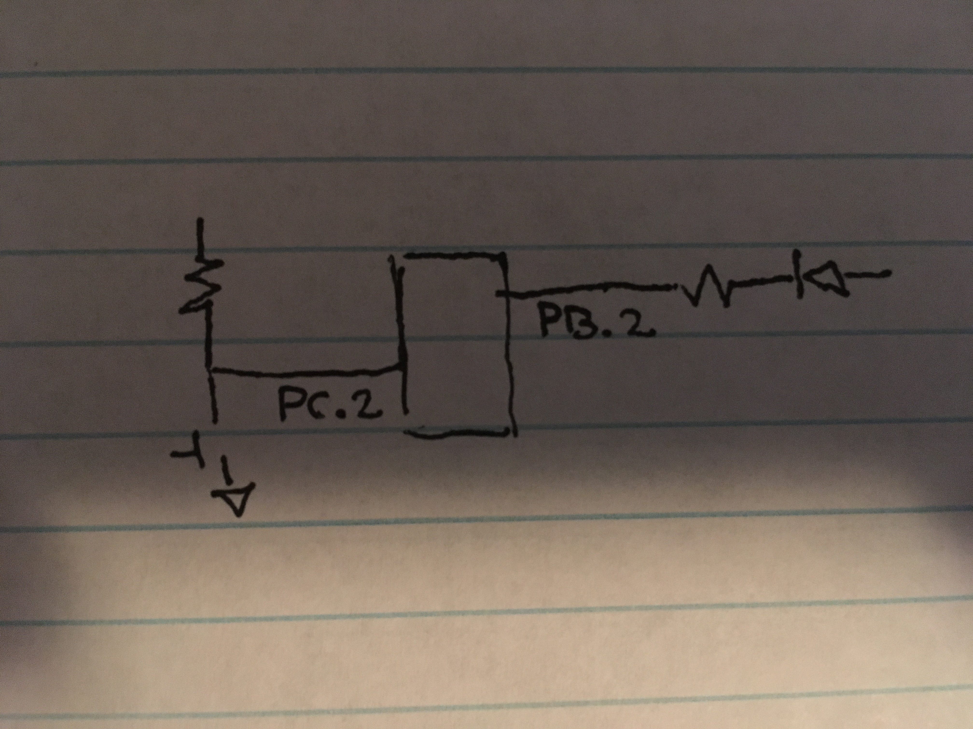

Schematic showing connections for PORTB.2 and PORTC.2

1. **SCREENSHOTS OF EACH TASK OUTPUT (ATMEL STUDIO OUTPUT)**

Not asked for in Design Assignment 2A instructions

1. **SCREENSHOT OF EACH DEMO (BOARD SETUP)**

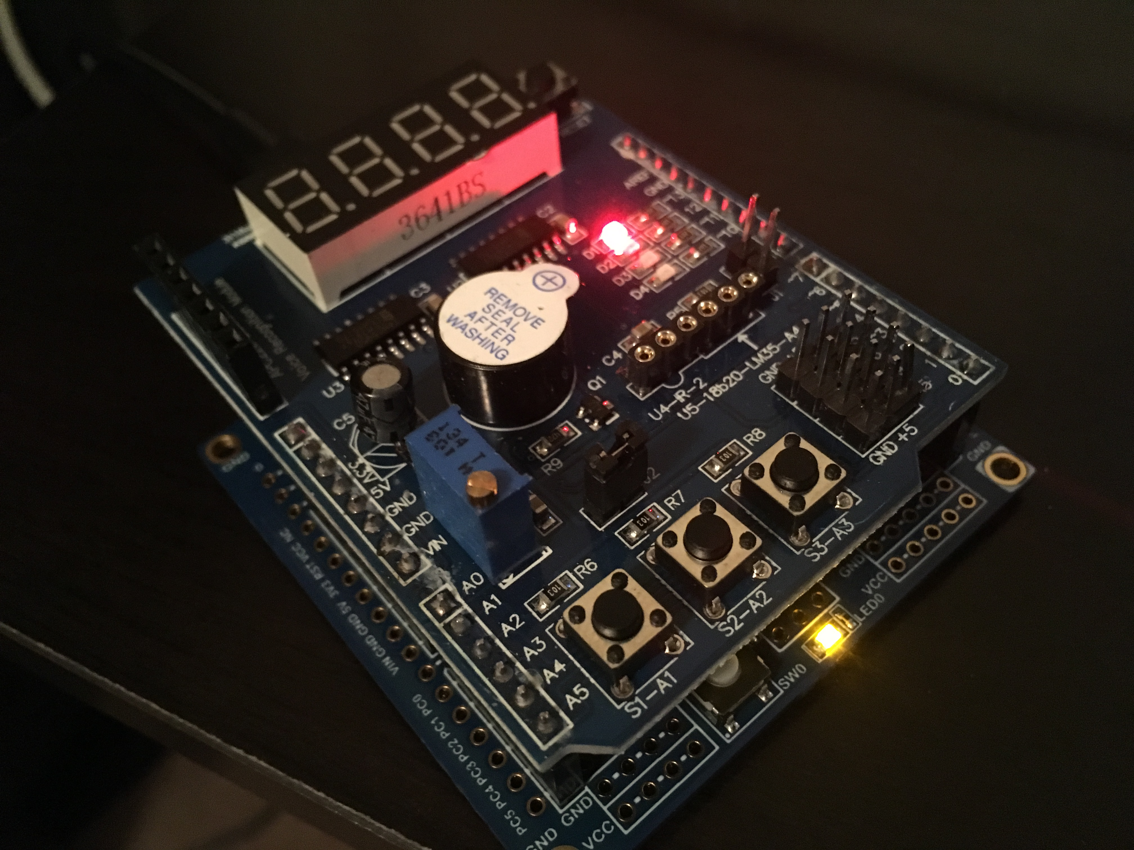

Board setup for Tasks 1 and 2 (Assembly and C)

1. **VIDEO LINKS OF EACH DEMO**

<https://youtu.be/qKaQFMzMypw>

1. **GITHUB LINK OF THIS DA**

https://github.com/portig1/submissions_E/tree/master/DA/LAB2C

**Student Academic Misconduct Policy**

<http://studentconduct.unlv.edu/misconduct/policy.html>

“This assignment submission is my own, original work”.

Geovanni Portillo